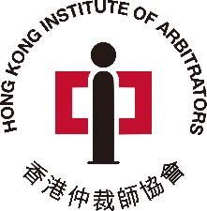

香 港 仲 裁 師 協 會
HONG KONG INSTITUTE OF ARBITRATORS

Patron: The Hon Chief Justice Andrew Cheung
Chief Justice of the Court of Final Appeal

HKIArb 2023 Annual Membership Subscription

Membership – ☐ Fellow ($1,500) / ☐ Associate ($1,000)

Payment information:

- By Cheque (HK$ only)
- Please note that only cheques issued by the banks in Hong Kong are accepted.
- Please make payable to “Hong Kong Institute of Arbitrators”

- By Bank Transfer/Telegraphic Transfer (Payer net of bank charges) **

Account No: | 511-768921-001
Name: | Hong Kong Institute of Arbitrators
Bank: | HSBC, 1 Queen’s Road Central, Hong Kong
Swift Code:  Remarks: | HSBC HK HHH KH  Bank Pay-In Slip is required

IMPORTANT: Failure to pay membership subscription by 31 January 2023 may result in membership being suspended or removed. Suspended or removed members shall no longer be entitled to use the designation of AHKIArb/FHKIArb or hold themselves out as HKIArb members.

** Please complete this form and return it together with the Payment Record or a Crossed Cheque to the following address:
Room 308, 3/F, West Wing, Justice Place, 11 Ice House Street, Central, Hong Kong **
Title:
First Name:
Last Name:
Email Address:
Annual Subscription Fee: | ☐ HK$1,500  ☐ HK$1,000
Company
Position
Contact Number:
Address:

